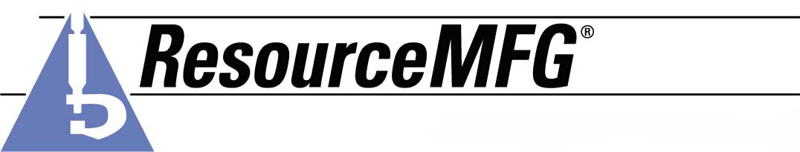

Joseph M. Shaw

Experience 2007-2007 Teletech Tucson, AZ
] Universal Agent
Using a multi-faceted computer program- tracked/Shipped packages throughout the United States, giving the Shipper/Receiver information as to progress of single/multiple shipments. Maintained professionalism and guidelines set up by UPS standards.

2005-2007 Temp Service Tucson, AZ
Office Supervisor
Customer service representative answered multi-line phone. Assisted with payroll, office inventory, dealt with vendors. Re-organized office area for better efficiency. Used Microsoft office and Internet. Maintained employee and client databases. Processed credit references for new clients

11/96 -2/97 Poiere & Poeere Woonsocket, RI
Drywall hanger Helper
- Measured and cut drywall
- Attached to walls and ceilings With drywall screws
- Cleaned up at the end of each job

1/94 –11/96 Atlantic Thermal Plastics Manufacturing Smith Field, RI
Machine operator
In charge 1 to 10 Line workers Depending on job
Take Through puts and ratio measurements

Clean hands And setups for next job

Education
- High school diploma

